SIMATS ENGINEERING
ASSESSMENT TOOL 2

COURSE NAME: INTERNET PROGRAMMING
COURSE CODE: CSA43

COURSE OUTCOME COVERED

CO-3: Implement dynamic web applications by utilizing DOM-based client-side scripting and employing Java Servlets for server-side request processing and response handling. (L3)

Assessment Tool : Technical Presentation
Weightage: 20%

QUESTIONS: Total Marks: 20
- Servlet Architecture & Workflow
Question:
Present the architecture of Java Servlets and explain the complete request–response cycle with a neat diagram.
Focus Areas:
- Client–Server interaction
- Role of Web Container
- Request and Response objects

Solution :

Answer
A Java Servlet is a server-side Java program that runs inside a Web Container such as Apache Tomcat. It is used to process client requests and generate dynamic responses.
1. Servlet Architecture
The main components of Servlet architecture are:
Client → Web Server → Web Container → Servlet → Database/Resources → Response → Client
Components
1. Client
The client is usually a web browser such as Chrome or Firefox. It sends an HTTP request to the server.

2. Web Server
The web server receives the request from the client and forwards it to the Web Container.
Example: Apache Tomcat
3. Web Container
The Web Container manages the servlet. Its main responsibilities are:
- Loading the servlet
- Creating the servlet object
- Managing the servlet life cycle
- Creating request and response objects
- Calling doGet() or doPost()
- Managing sessions
- Sending the response back to the client
4. Servlet
The servlet processes the client's request and generates a response.
Common methods are:
doGet()
doPost()
5. Database
The servlet can communicate with a database using JDBC to retrieve or store information.

2. Complete Request–Response Cycle
Step 1: Client Sends Request
The user enters a URL or submits an HTML form.
For example:
http://localhost:8080/StudentApp/StudentServlet
The browser sends an HTTP request to the server.
Step 2: Web Container Receives Request
The Web Container receives the HTTP request and identifies the servlet associated with the requested URL.
Step 3: Request and Response Objects
The Web Container creates:
HttpServletRequest
HttpServletResponse
The HttpServletRequest contains information sent by the client.
The HttpServletResponse is used to send information back to the client.
Step 4: Servlet Processes Request
The container calls the appropriate method:
GET → doGet()
POST → doPost()
Example:
protected void doGet(HttpServletRequest request,
HttpServletResponse response)
throws ServletException, IOException {

response.setContentType("text/html");

PrintWriter out = response.getWriter();

out.println("<h1>Hello Student</h1>");
}
Step 5: Database Processing
If required, the servlet communicates with a database using JDBC.
For example:
Servlet → JDBC → Database
The database returns the requested information.
Step 6: Servlet Creates Response
The servlet generates an HTTP response using the HttpServletResponse object.
The response can contain:
- HTML
- Text
- JSON
- Redirects
- Status codes
Step 7: Web Container Sends Response
The Web Container sends the generated HTTP response back to the client.
Step 8: Browser Displays Result
The browser receives the response and displays the result to the user.

3. Request and Response Objects
HttpServletRequest
HttpServletRequest represents the request from the client.
It can be used to retrieve:
- Form data
- Parameters
- HTTP headers
- Cookies
- Session information
Example:
String name = request.getParameter("name");
HttpServletResponse
HttpServletResponse represents the response sent by the servlet to the client.
Example:
response.setContentType("text/html");

PrintWriter out = response.getWriter();

out.println("<h2>Welcome Student</h2>");

4. Role of Web Container
The Web Container is the most important part of servlet architecture.
It performs the following functions:
- Loads the servlet class.
- Creates the servlet object.
- Calls init() when the servlet is initialized.
- Creates HttpServletRequest and HttpServletResponse.
- Calls service().
- service() invokes doGet() or doPost().
- Manages multiple client requests.
- Provides session management.
- Calls destroy() when the servlet is removed.

5. Simple Request–Response Diagram
For your exam, you can draw this:
CLIENT
(Web Browser)
|
| HTTP Request
↓
┌───────────────┐
│ WEB SERVER │
│ Tomcat │
└───────┬───────┘
|
↓
┌───────────────┐
│ WEB CONTAINER │
└───────┬───────┘
|
Request Object
Response Object
|
↓
┌───────────────┐
│ SERVLET │
│ doGet/doPost │
└───────┬───────┘
|
↓
┌───────────────┐
│ DATABASE │
└───────┬───────┘
|
↓
Generate Response
|
↓
WEB CONTAINER
|
| HTTP Response
↓
CLIENT
(Web Browser)
6. Short Conclusion
Servlet architecture follows a client-server model. The client sends an HTTP request to the Web Container. The container creates request and response objects and invokes the appropriate servlet method. The servlet processes the request, optionally accesses a database, generates a response, and sends it back through the Web Container to the client.

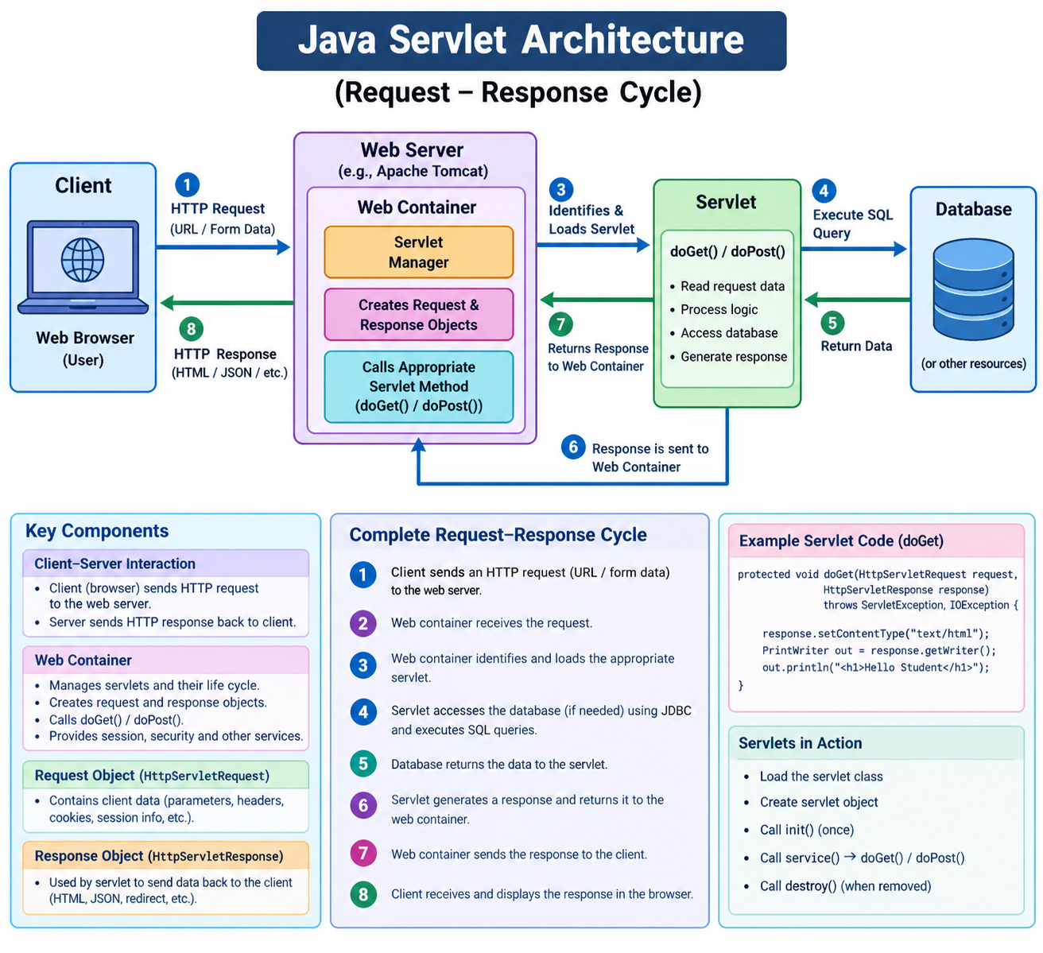

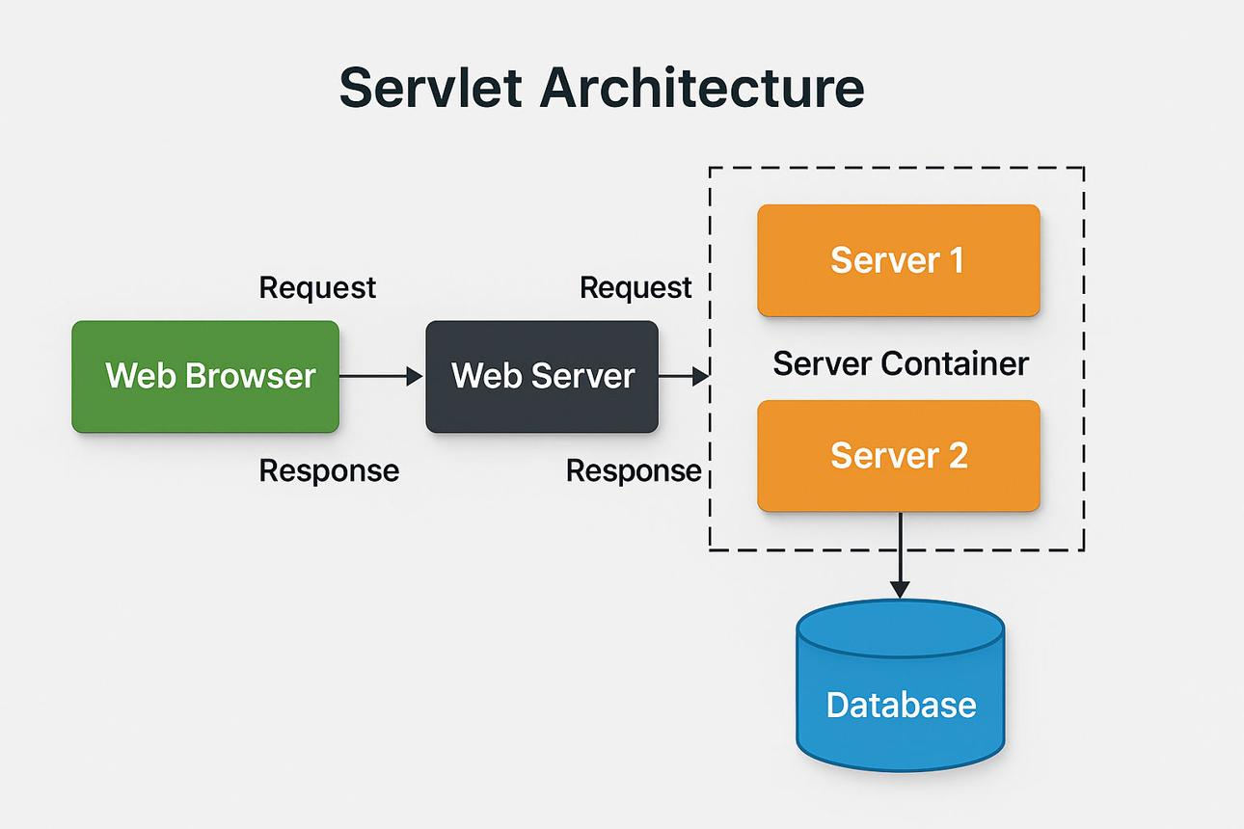

2. Servlet Life Cycle Analysis
Question:
Explain the Servlet Life Cycle with a sequence diagram and analyze the role of init(), service(), and destroy() methods.
Focus Areas:
- Life cycle phases
- Execution flow
- Performance implications

Answer
The Servlet Life Cycle describes the different stages a servlet goes through from its creation to its destruction. The entire life cycle is managed by the Web Container, such as Apache Tomcat.
The main stages are:
Loading → Instantiation → Initialization → Request Processing → Destruction

1. Servlet Life Cycle Phases
1. Loading
When the servlet is required, the Web Container loads the servlet class into memory.
Servlet Class
↓
Web Container
↓
Loaded into Memory
The servlet may be loaded when the first request arrives or when the server starts, depending on the configuration.

2. Instantiation
After loading the servlet class, the Web Container creates an object of the servlet.
StudentServlet.class
↓
new StudentServlet()
↓
Servlet Object
The container generally creates one servlet object and uses it to handle multiple requests.

3. Initialization – init()
The Web Container calls the init() method only once during the servlet's life cycle.
Example:
public void init() throws ServletException {
System.out.println("Servlet Initialized");
}
The init() method is used for:
- Initializing resources
- Reading configuration
- Creating required objects
- Establishing resources needed by the servlet
Example:
Servlet Created
↓
init()
↓
Servlet Ready

4. Request Processing – service()
For every client request, the Web Container calls the service() method.
protected void service(HttpServletRequest request,
HttpServletResponse response)
throws ServletException, IOException {

super.service(request, response);
}
The service() method determines the type of HTTP request.
service()
|
┌───────┴───────┐
↓ ↓
GET POST
↓ ↓
doGet() doPost()
Therefore:
GET → doGet()
POST → doPost()
The service() method is called for every request.

5. Destruction – destroy()
When the servlet is no longer required, the Web Container calls the destroy() method only once.
Example:
public void destroy() {
System.out.println("Servlet Destroyed");
}
It is used for:
- Closing database connections
- Closing files
- Releasing resources
- Performing cleanup operations
Servlet Running
↓
No Longer Required
↓
destroy()
↓
Servlet Removed

2. Servlet Life Cycle Sequence Diagram
You can draw this diagram in your exam:
CLIENT
|
| HTTP Request
↓
┌─────────────────┐
│ WEB CONTAINER │
│ (Tomcat) │
└────────┬────────┘
|
↓
Load Servlet Class
|
↓
Create Servlet Object
|
↓
init()
(Called Once)
|
↓
┌─────────────────┐
│ service() │
│ Called for each │
│ request │
└────────┬────────┘
|
┌──────┴──────┐
↓ ↓
doGet() doPost()
| |
└──────┬──────┘
↓
Generate Response
|
↓
CLIENT
|
|
More Requests
|
↓
service()
|
↓
service()
|
↓
Servlet No Longer
Required
|
↓
destroy()
(Called Once)
|
↓
Servlet Removed

3. Role of init(), service() and destroy()
init()
The init() method is called only once.
public void init() throws ServletException {
// Initialization code
}
Purpose:
- Initialize resources
- Read configuration
- Perform one-time setup
Performance:
Since it runs only once, expensive initialization does not need to be repeated for every request.

service()
The service() method is called for every client request.
protected void service(HttpServletRequest request,
HttpServletResponse response)
throws ServletException, IOException {

super.service(request, response);
}
It determines whether the request is:
GET → doGet()
POST → doPost()
Purpose:
- Process client requests
- Direct requests to the appropriate method
- Handle the main request-processing flow
Performance:
Because service() executes for every request, it should contain efficient code. Heavy or unnecessary processing can increase response time.

destroy()
The destroy() method is called only once before the servlet is removed.
public void destroy() {
// Cleanup code
}
Purpose:
- Close database connections
- Close files
- Release resources
- Perform cleanup
Performance:
Proper cleanup prevents memory leaks and resource exhaustion.

4. Execution Flow
The complete execution flow is:
1. Client sends HTTP request
↓
2. Web Container receives request
↓
3. Servlet class is loaded
↓
4. Servlet object is created
↓
5. init() is called once
↓
6. service() is called
↓
7. doGet() / doPost() is executed
↓
8. Response is generated
↓
9. Response is sent to client
↓
10. More requests → service() again
↓
11. Servlet is removed
↓
12. destroy() is called once

5. Performance Implications
Proper servlet life-cycle management improves application performance.
Using init() properly
Resources that are required throughout the servlet's life can be initialized once in init().
Good:
init() → Initialize once
service() → Reuse resource
Instead of:
Bad:
Every request → Initialize resource again
Repeated initialization can increase processing time.

Efficient service()
Since service() is called for every request, it should be efficient.
Many Requests
↓
service()
↓
Processing
↓
Response
Heavy processing inside service() can increase CPU usage and response time.

Proper destroy()
Resources should be released in destroy().
For example:
Database Connection
↓
destroy()
↓
Connection Closed
This helps prevent:
- Memory leaks
- Open database connections
- Resource exhaustion
- Poor server performance

6. Life Cycle Diagram to Remember
For your exam, this is the easiest diagram to remember:
Servlet Class
↓
Loading
↓
Instantiation
↓
init()
(Once only)
↓
service()
(Every request)
↓
┌──────┴──────┐
↓ ↓
doGet() doPost()
↓ ↓
└──────┬──────┘
↓
Response
↓
More Requests
↓
service()
↓
Servlet Removed
↓
destroy()
(Once only)
7. Difference Between the Three Methods
Method | Called | Purpose
init() | Once | Initialize resources
service() | For every request | Process requests
destroy() | Once | Release resources

Easy flow to remember

Loading
↓
Instantiation
↓
init() → Once
↓
service() → Every Request
↓
doGet()/doPost()
↓
Response
↓
service() → More Requests
↓
destroy() → Once
↓
End
8. Short Conclusion
The Servlet Life Cycle is completely managed by the Web Container. The servlet is first loaded and instantiated, then init() is called once for initialization. For every client request, service() is called and it invokes doGet() or doPost() according to the request type. When the servlet is removed from service, destroy() is called once to release resources. Proper use of these methods improves performance and prevents resource leaks.
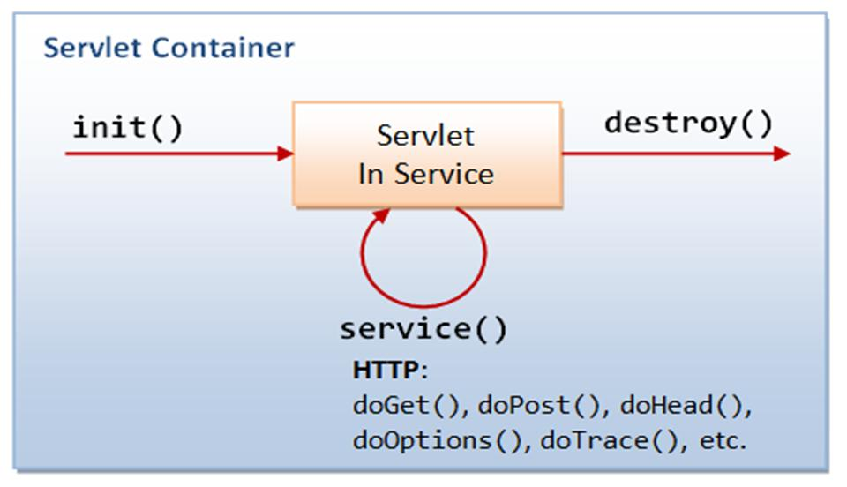
3. GET vs POST Method Evaluation
Question:
Compare GET and POST methods used in form submission. Present scenarios where each method is appropriate.
Focus Areas:
- Data transmission
- Security aspects
- URL limitations

Answer
GET and POST are HTTP methods used by web applications to send data from the client to the server. Both methods are commonly used when submitting HTML forms.
The main differences are in data transmission, security, URL visibility, and the amount of data that can be sent.

1. GET Method
The GET method sends form data as part of the URL.
Example
HTML form:
<form action="StudentServlet" method="get">

<input type="text" name="name">

<input type="text" name="department">

<input type="submit" value="Submit">

</form>
If the user enters:
Name: Ravi
Department: CSE
The browser sends a URL similar to:
StudentServlet?name=Ravi&department=CSE
In a Servlet, the data can be retrieved using:
String name = request.getParameter("name");
String department = request.getParameter("department");

2. POST Method
The POST method sends form data inside the HTTP request body instead of placing it in the URL.
Example
<form action="StudentServlet" method="post">

<input type="text" name="name">

<input type="text" name="department">

<input type="submit" value="Submit">

</form>
In the Servlet:
protected void doPost(HttpServletRequest request,
HttpServletResponse response)
throws ServletException, IOException {

String name = request.getParameter("name");

String department =
request.getParameter("department");
}
The data is not displayed directly in the URL.

3. GET vs POST Comparison
Feature | GET | POST
Data transmission | Data is sent in URL | Data is sent in request body
URL visibility | Data is visible in URL | Data is not normally visible in URL
Security | Less suitable for sensitive data | Better for sensitive data, especially with HTTPS
Data size | Limited by URL length | Can send much larger amounts of data
Bookmarking | Can be bookmarked | Generally not suitable for bookmarking submitted data
Browser history | Parameters may appear in history | Form data is not normally stored in URL history
Caching | Can be cached | Normally not cached in the same way
Servlet method | doGet() | doPost()
Common use | Search, filtering, retrieving data | Login, registration, inserting/updating data

4. Data Transmission
GET
GET attaches data to the URL.
Browser
↓
GET Request
↓
StudentServlet?name=Ravi&dept=CSE
Therefore, the data can be seen in the address bar.
POST
POST sends data in the request body.
Browser
↓
POST Request
↓
Request Body
↓
StudentServlet
The data does not appear in the URL.

5. Security Aspects
GET
GET is not recommended for sensitive information because the data appears in the URL.
For example:
login?username=ravi&password=12345
This can expose sensitive information through:
- Browser history
- Server logs
- Bookmarks
- Shared URLs
Therefore, GET should not be used for passwords or sensitive form data.
POST
POST is more appropriate for sensitive form submissions because the data is sent in the request body.
For example:
username = ravi
password = 12345
However, POST by itself does not provide encryption.
For secure transmission, use:
POST + HTTPS
HTTPS encrypts the communication between the browser and server.

6. URL Limitations
GET
GET has a limitation because the data is included in the URL.
Example:
StudentServlet?name=Ravi&department=CSE&year=3
URLs have practical length limits depending on browsers, servers, and other components.
Therefore, GET is not suitable for sending large amounts of data.
POST
POST sends data in the request body, so it is suitable for sending larger amounts of form data.
For example:
Registration Form
↓
POST
↓
Large Form Data
↓
Server
The server may still impose its own request-size limit.

7. When to Use GET
GET is appropriate when the operation is mainly retrieving information.
Examples
1. Search
Search: Java Servlet
↓
GET
↓
search?query=Java+Servlet
2. Product filtering
products?category=laptop&brand=dell
3. Viewing a page
student?id=101
GET is suitable when the data is not sensitive and the URL can safely represent the request.

8. When to Use POST
POST is appropriate when the operation submits or changes data.
Examples
1. Login
Username + Password
↓
POST
↓
Server
2. Student Registration
Student Details
↓
POST
↓
Database
3. Online Order
Product + Address + Order Details
↓
POST
↓
Server
4. Uploading Data
POST is also commonly used when sending larger form submissions or uploading files.

9. Simple Diagram
You can draw this in your exam:
FORM SUBMISSION
|
┌────────┴────────┐
↓ ↓
GET POST
| |
↓ ↓
Data in URL Data in Body
| |
↓ ↓
doGet() method doPost() method
| |
└────────┬────────┘
↓
SERVER
|
↓
RESPONSE

10. Example of GET and POST
GET Form
<form action="StudentServlet" method="get">

<input type="text" name="name">

<input type="submit" value="Search">

</form>
Servlet:
protected void doGet(HttpServletRequest request,
HttpServletResponse response)
throws ServletException, IOException {

String name = request.getParameter("name");

response.getWriter().println(
"Student Name: " + name
);
}
POST Form
<form action="StudentServlet" method="post">

<input type="text" name="name">

<input type="password" name="password">

<input type="submit" value="Login">

</form>
Servlet:
protected void doPost(HttpServletRequest request,
HttpServletResponse response)
throws ServletException, IOException {

String name = request.getParameter("name");

String password =
request.getParameter("password");

response.getWriter().println(
"Login Successful"
);
}

11. Advantages and Disadvantages
GET
Advantages:
- Simple and easy to use
- Data can be bookmarked
- Suitable for search operations
- Can be cached
- Useful for retrieving information
Disadvantages:
- Data is visible in URL
- Not suitable for passwords
- Limited URL length
- Not suitable for sensitive information
POST
Advantages:
- Data is not displayed in the URL
- Suitable for login and registration
- Suitable for larger form submissions
- Appropriate for creating or modifying data
Disadvantages:
- Cannot normally be bookmarked with the submitted data
- Requests may be repeated by users or browsers
- Requires appropriate security measures such as HTTPS

12. Quick Comparison to Remember
GET
↓
Data → URL
↓
Visible
↓
Limited Size
↓
Search / Retrieve
↓
doGet()

POST
↓
Data → Request Body
↓
Not in URL
↓
Larger Data
↓
Login / Registration / Submit
↓
doPost()

Short Conclusion:
GET and POST are HTTP methods used for transferring data between a client and server. GET sends data through the URL and is suitable for retrieving non-sensitive information such as search results. POST sends data in the request body and is more appropriate for login, registration, and other operations involving submitted or sensitive data. For sensitive information, POST should always be combined with HTTPS because POST alone does not encrypt data.

4. Session Tracking Techniques
Question:
Present different session tracking mechanisms (HttpSession, Cookies, URL rewriting). Evaluate their advantages and limitations.
Focus Areas:
- Session persistence
- Security concerns
- Use-case comparison

Answer:
Session tracking is a technique used by web applications to maintain information about a user across multiple requests.
HTTP is stateless, which means the server does not automatically remember a user between different requests. Session tracking mechanisms are used to maintain this information.
The main session tracking techniques are:
- HttpSession
- Cookies
- URL Rewriting

1. HttpSession
HttpSession is a Servlet API mechanism used to maintain user-specific information on the server.
When a user logs in, the server creates a session.
Example:
HttpSession session = request.getSession();

session.setAttribute("username", "student");
The stored information can be retrieved on another page:
HttpSession session = request.getSession();

String username =
(String) session.getAttribute("username");
The session is normally associated with a session ID, commonly sent to the client using a cookie such as JSESSIONID.
Example Flow
User Login
↓
Server creates HttpSession
↓
Session ID generated
↓
Browser stores Session ID
↓
User visits another page
↓
Session ID sent to server
↓
Server identifies the session
↓
User information retrieved
Advantages
- Session data is stored on the server.
- Suitable for login systems.
- Can store multiple values and objects.
- Easy to use in Servlets.
- Better suited than client-side storage for sensitive session state.
Limitations
- Uses server memory/resources.
- Sessions may expire after a timeout.
- Large numbers of users can increase server memory usage.
- Requires proper session security.

2. Cookies
A cookie is a small piece of data stored in the user's browser.
A Servlet can create a cookie using:
Cookie cookie =
new Cookie("username", "student");

response.addCookie(cookie);
The cookie can be retrieved later:
Cookie[] cookies =
request.getCookies();

Example Flow
Server
↓
Creates Cookie
↓
Browser stores Cookie
↓
User sends another request
↓
Cookie sent to Server
↓
Server reads Cookie
Advantages
- Easy to implement.
- Data can persist across multiple requests.
- Can have an expiration time.
- Useful for user preferences.
- Reduces the need to store small pieces of information on the server.
Limitations
- Stored on the client/browser.
- Users can delete or disable cookies.
- Cookie data can be viewed or modified by the client.
- Limited storage size.
- Should not be used to store passwords or other sensitive information directly.

3. URL Rewriting
URL rewriting is a session tracking technique where the session information is added to the URL.
Example:
http://example.com/profile;jsessionid=ABC123
In Servlets, URL rewriting can be performed using:
String url =
response.encodeURL("profile");

out.println(
"<a href='" + url + "'>Profile</a>"
);
If cookies are disabled, the server can include the session ID in the URL.
Example Flow
User
↓
Login
↓
Server creates Session
↓
Session ID added to URL
↓
/profile;jsessionid=ABC123
↓
User clicks another page
↓
Session ID sent to Server
↓
Server identifies Session
Advantages
- Can work when cookies are disabled.
- Does not depend on browser cookie support.
- Useful as a fallback session-tracking mechanism.
Limitations
- Session ID becomes visible in the URL.
- URL can appear in browser history.
- URL can be copied or shared.
- Less secure than cookie-based session tracking.
- URLs become longer and less readable.

4. Comparison of Session Tracking Techniques
Feature | HttpSession | Cookies | URL Rewriting
Data location | Server | Client/Browser | Session ID in URL
Session persistence | Good | Good | Good while URL is maintained
Security | Relatively better | Depends on cookie settings | Lower
Storage | Server-side | Client-side | URL
Requires cookies | Usually uses a session cookie by default | Yes | No
Data visible to user | No session data directly | Cookie data can be viewed | Session ID visible in URL
Storage capacity | Server dependent | Limited | Limited by URL length
Easy to use | Very easy | Easy | Moderate
Best use | Login/session management | Preferences/small data | Fallback when cookies are disabled

5. Session Persistence
Session persistence means maintaining a user's information across multiple requests.
For example:
Login Page
↓
Home Page
↓
Profile Page
↓
Shopping Cart
↓
Logout
The user should remain logged in while moving between these pages.
Using HttpSession
HttpSession session =
request.getSession();

session.setAttribute(
"username",
"student"
);
On another page:
HttpSession session =
request.getSession();

String username =
(String) session.getAttribute("username");
Thus, the username remains available across multiple requests.

6. Security Concerns
HttpSession
HttpSession is generally preferred for maintaining authentication state because the actual session data is stored on the server.
Important security practices include:
- Use HTTPS.
- Use secure session cookies.
- Set appropriate session timeouts.
- Invalidate the session during logout.
Example:
session.invalidate();

Cookies
Cookies can be protected using attributes such as:
Secure
HttpOnly
SameSite
HttpOnly helps prevent client-side JavaScript from accessing the cookie.
Secure ensures the cookie is sent only over HTTPS.

URL Rewriting
URL rewriting has an important security concern because the session ID may appear in the URL.
For example:
/profile;jsessionid=ABC123
This can potentially expose the session ID through:
- Browser history
- Shared URLs
- Server logs
- Referrer information
Therefore, URL rewriting should generally be used as a fallback when cookies are unavailable.

7. Use-Case Comparison
HttpSession
Best suited for:
Login systems
Student portals
Shopping carts
Banking applications
User dashboards
Example:
Login
↓
HttpSession
↓
Home
↓
Profile
↓
Logout

Cookies
Best suited for:
Language preference
Theme preference
Remembering non-sensitive settings
Shopping preferences
Example:
User selects Dark Mode
↓
Cookie stores preference
↓
User returns later
↓
Dark Mode is restored

URL Rewriting
Best suited for:
When cookies are disabled
Fallback session tracking
Older browser environments
Example:
/profile;jsessionid=ABC123

8. Simple Diagram
You can draw this in your exam:
SESSION TRACKING
|
┌─────────────┼─────────────┐
↓ ↓ ↓
HttpSession Cookies URL Rewriting
| | |
↓ ↓ ↓
Server Side Client Side URL Based
| | |
↓ ↓ ↓
Login/Cart Preferences Cookies
User Session Small Data Disabled

9. Overall Session Tracking Flow
CLIENT
(Web Browser)
|
| Login Request
↓
WEB SERVER
|
↓
WEB CONTAINER
|
┌────────┼────────┐
↓ ↓ ↓
HttpSession Cookies URL Rewriting
| | |
└────────┼────────┘
↓
Session Maintained
|
↓
Multiple Web Pages
|
↓
Logout
|
↓
Session Invalidated
10. Advantages and Limitations Summary
HttpSession
Advantages:
- Server-side storage
- Easy to use
- Suitable for authentication
- Can store multiple attributes
Limitations:
- Uses server resources
- Session timeout can occur
- Requires proper session security
Cookies
Advantages:
- Simple
- Persistent
- Useful for preferences
- Reduces server-side storage for small data
Limitations:
- Client-side storage
- Can be deleted or disabled
- Limited size
- Should not store passwords
URL Rewriting
Advantages:
- Works without cookies
- Useful as a fallback
- Easy to implement using encodeURL()
Limitations:
- Session ID visible in URL
- Security risk
- URLs become longer
- Can be copied or shared

⭐ Easy Flow to Remember
HttpSession
↓
Server stores session data
↓
Best for Login

Cookies
↓
Browser stores small data
↓
Best for Preferences

URL Rewriting
↓
Session ID added to URL
↓
Best when Cookies are Disabled
Short Conclusion
Session tracking is used to maintain a user's state across multiple HTTP requests. HttpSession is commonly preferred for login and authentication because session data is maintained on the server. Cookies are useful for storing small client-side information such as preferences. URL rewriting can be used as a fallback when cookies are disabled, but it has greater security risks because the session ID may appear in the URL.

5. Cookies vs Sessions – Critical Analysis
Question:
Analyze and compare Cookies and Sessions in web applications. Present real-time use cases.
Focus Areas:
- Storage location
- Security risks
- Performance considerations

Answer:

Cookies and Sessions are mechanisms used by web applications to maintain information about users across multiple HTTP requests.
HTTP is stateless, so the server does not automatically remember previous requests. Cookies and sessions help maintain user state.
The main difference is where the information is stored:
Cookie → Data stored on Client / Browser
Session → Data stored on Server

1. Cookies
A cookie is a small piece of information stored in the user's web browser.
The server sends a cookie to the browser, and the browser sends it back with future requests.
Example
Cookie cookie =
new Cookie("username", "student");

response.addCookie(cookie);
The cookie can later be read using:
Cookie[] cookies =
request.getCookies();
Working of Cookies
SERVER
|
| Set-Cookie
↓
BROWSER
|
Stores Cookie
|
↓
Next Request
|
| Cookie
↓
SERVER

2. Sessions
A session stores user information on the server.
In Java Servlets, HttpSession is commonly used.
Example
HttpSession session =
request.getSession();

session.setAttribute(
"username",
"student"
);
The information can be retrieved later:
HttpSession session =
request.getSession();

String username =
(String) session.getAttribute("username");
Working of Sessions
CLIENT
|
Login Request
↓
SERVER
|
Create Session
|
Session ID
↓
CLIENT
|
Session ID
↓
SERVER
|
Find Session Data
↓
User Information
In Servlet applications, the session ID is commonly maintained using a cookie such as JSESSIONID.

3. Storage Location
Cookies
Cookies are stored on the client/browser.
Browser
↓
Cookie
↓
Client Storage
Examples of information that may be stored:
- Language preference
- Theme preference
- Non-sensitive user settings
- Session identifier

Sessions
Session information is stored on the server.
Browser
↓
Session ID
↓
Server
↓
Session Data
The browser normally stores only the session identifier, while the actual session data is maintained by the server.

4. Security Risks
Cookies
Cookies have some security risks because they are stored on the client.
A user can potentially:
- Delete cookies
- View cookie values
- Modify non-protected cookies
- Disable cookies
Sensitive information such as passwords should not be stored directly in cookies.
Security attributes can help protect cookies:
Secure
HttpOnly
SameSite
HttpOnly helps prevent JavaScript from reading the cookie.
Secure ensures the cookie is sent over HTTPS.

Sessions
Sessions are generally safer for storing application state because the actual session data is maintained on the server.
However, sessions can still be attacked if the session ID is stolen.
Security practices include:
- Use HTTPS.
- Protect session cookies.
- Use appropriate session timeouts.
- Invalidate sessions during logout.
- Prevent session fixation.
Example:
session.invalidate();

5. Performance Considerations
Cookies
Cookies can reduce server-side storage because small amounts of information are stored on the client.
However, cookies are sent with requests to the relevant server, so excessive cookie data can increase request size and network traffic.
Large Cookies
↓
Larger HTTP Requests
↓
More Network Traffic
Therefore, cookies should generally contain only small amounts of appropriate data.

Sessions
Sessions require server-side resources.
For example:
100 Users
↓
100 Active Sessions
↓
Server Memory / Resources
If a large number of users have active sessions, server memory usage can increase.
Proper session expiration and cleanup are therefore important.

6. Cookies vs Sessions Comparison
Feature | Cookies | Sessions
Storage location | Client / Browser | Server
Data stored | Small data | User/session data
Security | More exposed to client | Actual data stays on server
Size | Limited | Depends on server resources
Server memory | Usually less required | Required
Performance | Small cookies are lightweight | Uses server resources
Persistence | Can persist for a specified time | Usually expires after timeout/invalidation
User can disable it | Yes | Session tracking may be affected if cookies are required
Best use | Preferences, small data | Login and authentication
Servlet API | Cookie | HttpSession

7. Real-Time Use Cases
Use Case 1: Online Shopping Website
Cookies
Cookies can be used to remember:
Language
Theme
Recently viewed products
Shopping preferences
Example:
User selects English
↓
Cookie stores preference
↓
User returns later
↓
English is selected
Sessions
Sessions can maintain:
Login status
Shopping cart
User information
Checkout state
Example:
Login
↓
Session Created
↓
Browse Products
↓
Add to Cart
↓
Checkout
↓
Logout

8. Use Case 2: Student Portal
A student logs into an online college portal.
Username + Password
↓
Login
↓
HttpSession Created
↓
┌──────┼────────┐
↓ ↓ ↓
Home Profile Results
↓
Logout
↓
Session Invalidated
Here, Session is more appropriate because login information should be maintained securely on the server.

9. Use Case 3: E-Commerce Preferences
A shopping website remembers the user's selected language and theme.
User selects:
Dark Mode + English
↓
Cookie
↓
Browser stores preference
↓
User returns later
↓
Preferences restored
Here, Cookies are appropriate because the information is small and related to user preferences.

10. Advantages and Disadvantages
Cookies
Advantages:
- Simple to implement
- Can persist for a long time
- Useful for preferences
- Reduces server-side storage
Disadvantages:
- Stored on the client
- Can be deleted or disabled
- Limited storage
- Should not contain sensitive information directly

Sessions
Advantages:
- Actual session data is stored on the server
- Suitable for authentication
- Can store multiple attributes
- Useful for shopping carts and user accounts
Disadvantages:
- Uses server memory/resources
- Sessions can expire
- Large numbers of users can increase server resource usage
- Session IDs must be protected

11. Simple Comparison Diagram
You can draw this in your exam:
WEB APPLICATION
|
┌─────────┴─────────┐
↓ ↓
COOKIES SESSIONS
| |
↓ ↓
Client / Browser Server
| |
↓ ↓
Small Data User Data
| |
↓ ↓
Preferences Login / Cart

12. Overall Working
USER
|
↓
Web Application
|
┌──────┴──────┐
↓ ↓
Cookie Session
↓ ↓
Browser Server
↓ ↓
Preferences Login Data
↓ ↓
└──────┬──────┘
↓
User State Maintained
Easy Flow to Remember
COOKIE
↓
Client / Browser
↓
Small Data
↓
Preferences
↓
Less Server Storage

SESSION
↓
Server
↓
User Data
↓
Login / Cart
↓
More Server Resources
Short Conclusion
Cookies and Sessions are important techniques for maintaining user state in web applications. Cookies store small amounts of information on the client and are suitable for preferences and non-sensitive data. Sessions store user-related information on the server and are more suitable for authentication, shopping carts, and other application state. Cookies generally reduce server-side storage, while sessions consume server resources but keep the actual session data on the server. For sensitive applications, sessions combined with HTTPS and secure session-cookie settings are generally preferred.

Code of Conduct:

I yuvan shankar (192511072) certify that this submission is my original work and that I have adhered to the guidelines specified for this assessment.
I understand that any violation of academic integrity rules will result in disciplinary action.

Signature of the student:
Yuvan shankar L

RUBRICS FOR CALCULATION:

Technical Presentation
Criteria | Weightage | Level 4 – Exemplary | Level 3 – Proficient | Level 2 – Developing | Level 1 – Beginning
Technical Content Accuracy | 30 | Highly accurate, in-depth, and insightful technical explanation | Technically correct content with adequate depth and clarity | Basic concepts presented with limited accuracy and depth | Content contains major technical errors; concepts poorly understood
Problem Identification | 25 | Problem rigorously analyzed using appropriate and advanced methods | Problem clearly defined with a logical engineering approach | Problem identified but analysis or methodology is weak | Problem statement unclear or incorrect; no logical approach
Use of Tools | 20 | Advanced tools, well-analyzed data, and highly effective visuals | Appropriate tools and data used effectively with clear visuals | Limited use of tools and basic data interpretation | Minimal or incorrect use of tools and data; poor visuals
Communication | 15 | Highly engaging, confident, and audience-focused delivery | Clear, organized, and professional communication | Understandable but lacks clarity, structure, or confidence | Poor organization, unclear speech, ineffective slides
Professionalism | 10 | Exemplary professionalism, leadership, and ethical awareness | Professional conduct with effective team collaboration | Basic professionalism; uneven team participation | Lacks professionalism; minimal contribution or ethical awareness

